Practical 1

**AIM :- INTRODUCTION**

1) History of python?

ans)

* Python was develop by Guido van Rossum in 1989 at Centrum Wiskunde & Informatica (CWI) in the Netherlands.
* After two year of test the python was released on 20th feb 1991 as open source programming language.
* He named it after the television show Monty Python's Flying Circus. ... as it was his favorite Television show.
* ABC programming language is said to be the predecessor of Python language which was capable of Exception Handling and interfacing with Amoeba Operating System.

2) Differentiate compiler and interpreter.

Ans)

* Compiler takes whole program at a time where interpreter takes single line of code or instruction at a time.
* Compiler is faster where interpreter is comparatively slow to compiler.
* Continues translating the program until the first error is met, in which case it stops. Hence debugging is easy where in interpreter it generates the error message only after scanning the whole program. Hence debugging is comparatively hard.
* Compliers generate intermediate machine code where interpreter never generates any intermediate machine code.
* Programing language using compiler are C,C++,C#, Scala, Java where programing language use interpreter are PHP, Perl, Ruby,python.

3) What types of applications can be developed by using Python?

Ans)

* Web application using Django,flask.
* App development using pyramid.
* Machine Learning using pandas or scikit.
* Artificial language
* Data analysis
* GUI Development using Tkinter.
* IOT
* Block chain

4) List down Python versions.

Ans)

* Python 1.0 in January 1994.
* Python 2.0 in October 16, 2000.
* Python 3.0 in December 3, 2008.
* Python 3.7 in June 27, 2018.
* Python 3.8 in 18 Dec 2019.

5) List out Python IDE.

Ans)

* **Spyder**: - Spyder is an open-source IDE usually used for scientific development. Spyder has some great features such as autocompletion, debugging and iPython shell. However, it lacks in features compared to PyCharm.

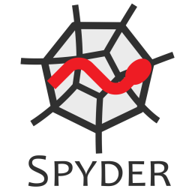

* **Sublime Text**:-Sublime Text is a popular code editor that supports many languages including Python. It's fast, highly customizable and has a huge community.



* **Atom**:-Atom is an open-source code editor developed by Github that can be used for Python development (similar Sublime text)..

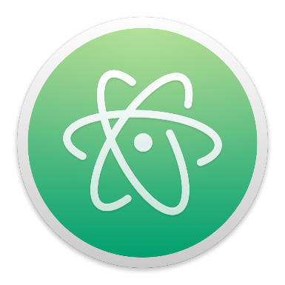

* **PyCharm**: - PyCharm is an IDE for professional developers. It is created by JetBrains, a company known for creating great software development tools.

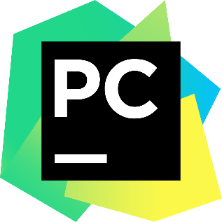

* **Thonny**:-Thonny is a Python dedicated IDE that comes with Python 3 built-in. Once you install it, you can start writing Python code.



6) List out the features of the Python.

Ans)

* **Easy to Learn and Use**: - Python is easy to learn and use. It is developer-friendly and high level programming language.
* **Expressive Language**: - Python language is more expressive means that it is more understandable and readable.
* **Interpreted Language**: - Python is an interpreted language i.e. interpreter executes the code line by line at a time. This makes debugging easy and thus suitable for beginners.
* **Cross-platform Language**: - Python can run equally on different platforms such as Windows, Linux, Unix and Macintosh etc. So, we can say that Python is a portable language.
* **Free and Open Source:** - Python language is freely available at official web address. The source-code is also available. Therefore it is open source.
* **Object-Oriented Language**: - Python supports object oriented language and concepts of classes and objects come into existence.
* **Extensible**: - It implies that other languages such as C/C++ can be used to compile the code and thus it can be used further in our python code.
* **Large Standard Library**: - Python has a large and broad library and provides rich set of module and functions for rapid application development.
* **GUI Programming Support**: - Graphical user interfaces can be developed using Python.
* **Integrated**: - It can be easily integrated with languages like C, C++, and JAVA etc.

7) Write advantages of python languages over other languages.

Ans)

1. **Presence of Third Party Modules:** The Python Package Index (PyPI) contains numerous third-party modules that make Python capable of interacting with most of the other languages and platforms.
2. **Extensive Support Libraries:** Python provides a large standard library which includes areas like internet protocols, string operations, web services tools and operating system interfaces. Many high use programming tasks have already been scripted into the standard library which reduces length of code to be written significantly.
3. **Open Source and Community Development:** Python language is developed under an OSI-approved open source license, which makes it free to use and distribute, including for commercial purposes.
4. **Learning Ease and Support Available:** Python offers excellent readability and uncluttered simple-to-learn syntax which helps beginners to utilize this programming language. The code style guidelines, PEP 8, provide a set of rules to facilitate the formatting of code. Additionally, the wide base of users and active developers has resulted in a rich internet resource bank to encourage development and the continued adoption of the language.
5. **User-friendly Data Structures:** Python has built-in list and dictionary data structures which can be used to construct fast runtime data structures. Further, Python also provides the option of dynamic high-level data typing which reduces the length of support code that is needed.
6. **Productivity and Speed:** Python has clean object-oriented design, provides enhanced process control capabilities, and possesses strong integration and text processing capabilities and its own unit testing framework, all of which contribute to the increase in its speed and productivity. Python is considered a viable option for building complex multi-protocol network applications.

7) Differentiate dynamic and static types of programming.

Ans)

|  |  |
| --- | --- |
| **Static Languages** | **Dynamic Languages** |
| Type declaration required. | Type declaration not required. |
| Less productive. | More productive. |
| Memory allocation is done at compiler or runtime. | Memory allocation is done at runtime. |
| Less flexible. | More flexible. |
| Only few languages support automatic memory management. | Automatic memory management is available. |
| More reliable. | Less reliable. |

8) Differentiate Procedural and object oriented programming.

Ans)

|  |  |
| --- | --- |
| **Procedural Oriented Programming** | **Object Oriented Programming** |
| Large program is divided into units called functions. | Entire program is divided into objects. |
| No access specifier observed. | Access specifier are "public", "private", "protected". |
| Top-down approach. | Bottom-up approach. |
| Neither it overload functions nor operators. | It overloads functions, constructors, and operators. |
| There is no proper way of hiding the data, so data is insecure | Data is hidden in three modes public, private, and protected. hence data security increases. |
| No concept of virtual classes . | Concept of virtual function appear during inheritance. |
| Global data is shared among the functions in the program. | Data is shared among the objects through the member functions. |
| Example:- C, VB, FORTRAN, Pascal | Example:- C++, JAVA, VB.NET, C#.NET. |